Case Study 1: Student Pass/Fail Prediction

Scenario
A college wants to build an Artificial Intelligence (AI) model that can predict whether a student will Pass or Fail in the final examination. The prediction is based on three important factors:
- Study Hours
- Attendance Percentage
- Assignment Marks
The college has collected information from 500 students. The goal is to use this data to train a neural network that can accurately predict the result of a new student. This system can help teachers identify students who need extra support and guidance before the final exams.

1. Which neural network architecture is more suitable? Justify your answer.
A Single Hidden Layer Neural Network (MLP) is the most suitable architecture for this problem.
This problem has only three input features, and the relationship between these features and the final result is not very complex. A single hidden layer is capable of learning these patterns and making accurate predictions. Since the dataset contains 500 student records, a deeper network with multiple hidden layers is not necessary. Using one hidden layer also reduces training time, lowers computational cost, and decreases the chance of overfitting. Therefore, a single hidden layer provides a good balance between simplicity and prediction accuracy.

2. Identify the Input Layer, Hidden Layer(s), and Output Layer

Input Layer (3 Neurons)
The input layer receives the student's information:
- Study Hours
- Attendance
- Assignment Marks

Hidden Layer (5 Neurons)
The hidden layer processes the input data, learns important patterns, and helps the model make better predictions.

Output Layer (1 Neuron)
The output layer gives the final prediction:
- 1 = Pass
- 0 = Fail

3. Neural Network Architecture (One Hidden Layer with 5 Neurons)
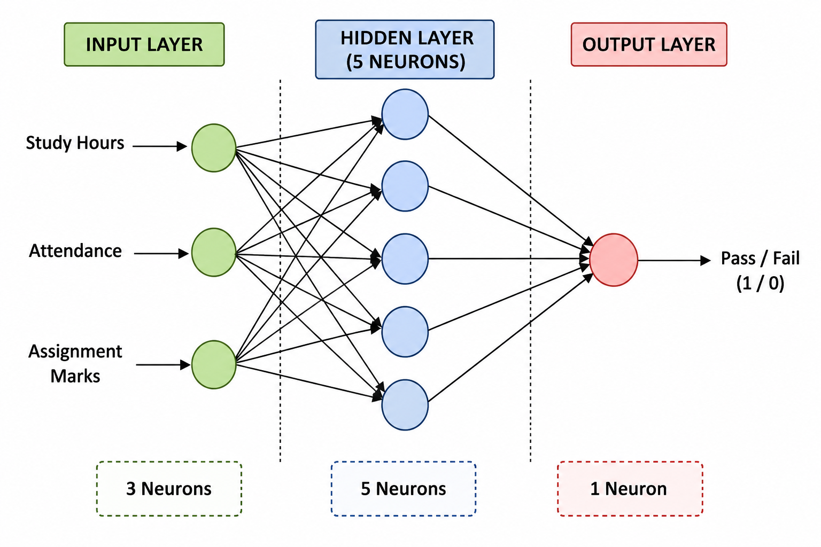

4. Why is a Single Hidden Layer Sufficient?
A single hidden layer is enough because the dataset contains only three input features, making the problem relatively simple. The hidden layer can learn the relationship between study hours, attendance, assignment marks, and the student's final result. It also provides good prediction accuracy while keeping the model easy to train. Compared to multiple hidden layers, it requires less computation, trains faster, and is less likely to overfit the training data. For a dataset of 500 students, a single hidden layer is both efficient and effective.

Advantages of Using a Single Hidden Layer
- Easy to design and implement.
- Requires less training time.
- Provides good accuracy for simple prediction problems.
- Uses fewer computational resources.
- Reduces the risk of overfitting.
- Suitable for small and medium-sized datasets.

Applications
- Student performance prediction.
- Exam result prediction.
- Employee performance evaluation.
- Customer classification.
- Loan approval prediction.
- Basic medical diagnosis.

Conclusion
A Single Hidden Layer Neural Network is the best choice for predicting whether a student will Pass or Fail based on Study Hours, Attendance, and Assignment Marks. It is simple, efficient, and provides accurate results for this type of classification problem. With 3 input neurons, 5 hidden neurons, and 1 output neuron, the model can learn meaningful patterns from the data and assist educational institutions in identifying students who may require additional academic support.

NAME: A.Ram charan
REG NO: 192425198

